Discuss2

Q1.
CPU, memory, IO device

- CPU, memory, and a number of device controllers are connected to the system bus.
- Memory : store program and data
- Each I/O device controller is in charge of a particular device type.
- Each I/O device controller has a local buffer.
- CPU moves data from/to main memory to/from the local I/O buffers.
- I/O is from the device to local buffer of controller.
- I/O devices and the CPU can execute concurrently.
- Device controller informs CPU that it has finished its operation by causing an interrupt.
Q2.
Program counter – control the execution sequence
Accumulator – store the AL results.
Data register – store intermediate results of a task.
Address register – store address of operands.
Stack register – store the address of the last stored element in the stack
Flag register – store the outcome of arithmetic operations.

Q3.
- The address is sent out on the address bus.
- A memory-read signal is sent out on the control bus.
- The memory outputs the instruction byte on the data bus
- The CPU read the instruction byte and decodes it. (repeat 1-4 until the complete instruction is read).

Q4.
The number of bits a CPU’s ALU can work with at a time determine if the CPU is an 8-bit, 16-bit, or 32-bit.

Q5.
The stack is a last-in-first-out (LIFO) data structure, which is used to store the returning address in subroutine calls and the processor status during interrupt.

location content

101h cch
100h 0ah
0ffh 10h

New SP = 101h

True or False
- A general purpose microprocessor has on-chip ROM. F
- A microcontroller has on-chip ROM. T
- A microcontroller has on-chip I/O ports. T
- A microcontroller has a fixed amount of RAM on the chip T.

- What components are normally put together with CPU into a single chip?
timer, IO port, serial port, rom, ram

11
An instruction cycle may be divided into several phases:

Instruction Fetch:
1) The CPU places the content of the program counter on the address bus in order to fetch an instruction from memory,

2) The program counter is incremented so as to be ready to fetch the next instruction,

3) After the data in the data bus is ready, the CPU places it (the instruction) in the instruction register ready for decoding,

Instruction Decode:

The instruction decoder decodes the instruction to identify:
i) the operation to be carried out,
ii) the address of the source operands and the results,

Instruction Execution:
1) Additional memory accesses may be conducted to obtain all the operands needed (if any),
2) The specified operation will be performed,

3) The results are placed according to the destination address so determined. Again, additional memory access may be required (if any),
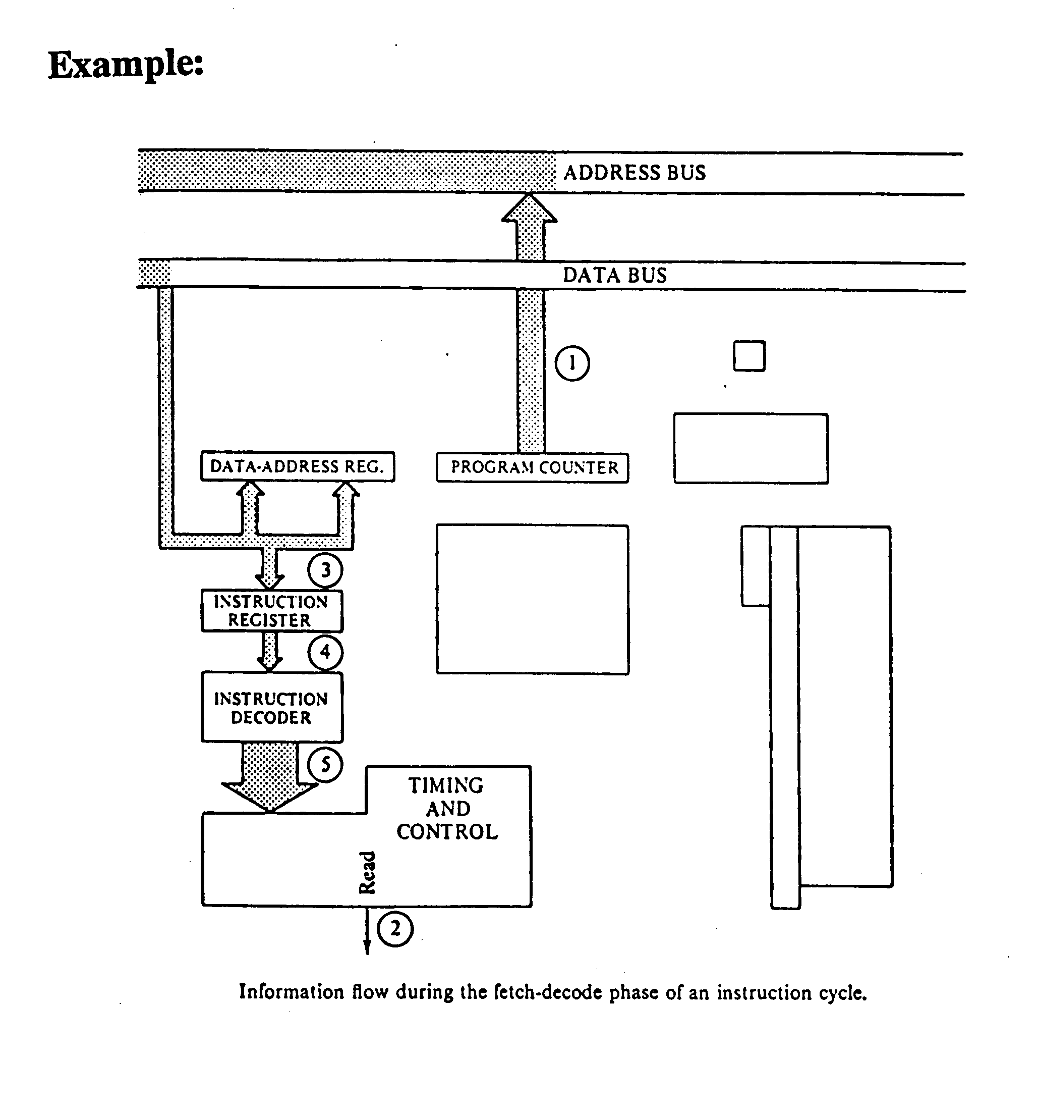
Q12.
The data is already in the execution unit; therefore, it can be accessed much more quickly than it could in the memory.

